|  |
| --- |
| **Curriculum vitae** |

**Name: Pravin Dhundale**

**Mobile No:** +917379033713 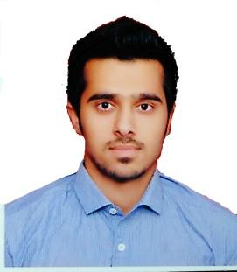

**E-Mail ID:** [**pravin.bhumca15**](mailto:pravin.bhumca15)[*@gmail.com*](mailto:Pravin.bhumca15@gmail.com)

**CARRIER OBJECTIVES:**

To work for an organization which provides me the opportunity to improve my skills and knowledge to growth along with the organization objective.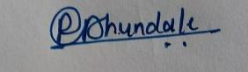

**Name** : Pravin Dhundale

**Father’s name** : Prakash Dhundale

**Date of Birth** : 23th july , 1994.

**Nationality**  : Indian

**Sex** : Male

**Marital status** : Single

**Language known** : ENGLISH (Read, Speak & Write),

MARATHI (Read, Speak ),

HINDI (Speak, Read & Write)

**PROFESSIONAL QUALIFICATION:-**

|  |  |  |  |  |  |  |  |  |  |
| --- | --- | --- | --- | --- | --- | --- | --- | --- | --- |
| |  | | --- | | **NAME OF EXAM** | | |  | | --- | | **UNIVERSITY** | | |  | | --- | | **YEAR** | | |  | | --- | | **SGPA** | | |  | | --- | | **CGPA** | |
| |  | | --- | | M.C.A.2ndSem | | |  | | --- | | B.H.U. | | 2015-2016 | 7.78 | 7.89 |
| |  | | --- | | M.C.A.1stSem | | |  | | --- | | B.H.U. | | 2015-2016 | 8.00 |  |

**ACADEMIC QUALIFICATION:**

|  |  |  |  |
| --- | --- | --- | --- |
| **EXAMINATION**  **PASSED** | **BOARD/**  **UNIVERSITY** | **YEAR OF PASSING** | **RESULTS** |
| B.Sc..(Computer Science) | D.A.V.V | 2013 | 64.72% |
| Intermediate | M.P Borad | 2011 | 62% |
| High Secondary | M.P Board | 2009 | 62% |

**TECHNICAL PROFICIENCY:**

**Languages** **:** C Language , JAVA (CORE), SQL.

**Area of Interest**  **:** C

**KEY STRENGTH:**

* Quick Learning.
* Self Motivated.
* Making new friends

**ACHIEVEMENTS:**

* 1st  Prize winner in  **Mime Competition** in **“DISHA”** in 2015.

.

**HOBBIES:**

* Playing games in computer.
* Watching cricket.

**DECLARATION:**

I hereby declare that all the information provided by me in this application is factual and correct to the best of my knowledge and belief.

**………………………….**

**DATE :**  Signature

**PLACE :** Varanasi (Pravin dhundale)